**EXPERIMENT-2**

**NAME – SANCHIT JAIN**

**BATCH – B-7**

**ENROLL – 21103192**

**Aim:**

To determine the resistivity of semiconductors by Four probe Method.

**Formula Used:**

The function, f(w/S) is a divisor for computing resistivity which depends on the value of w and S We assume that the size of the metal tip is infinitesimal and sample thickness is greater than the distance between the probes**.**

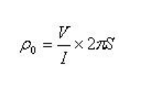

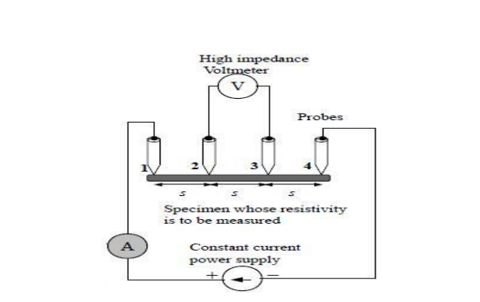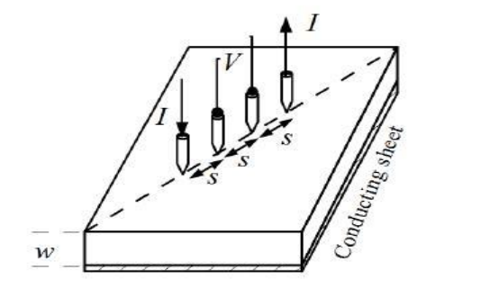

**OBSERVATION TABLE:**

Current-11mA

Voltage range – 1V

Current range – 200mA

|  |  |  |
| --- | --- | --- |
| **Temperature** | **Voltage** | **Resistivity** |
| 30 | 0.31 | 6.01 |
| 35 | 0.30 | 5.84 |
| 40 | 0.29 | 5.68 |
| 45 | 0.28 | 5.52 |
| 50 | 0.27 | 5.38 |
| 55 | 0.27 | 5.24 |
| 60 | 0.26 | 5.11 |
| 65 | 0.25 | 4.99 |
| 70 | 0.25 | 4.88 |
| 75 | 0.24 | 4.77 |
| 80 | 0.24 | 4.66 |
| 85 | 0.23 | 4.56 |
| 90 | 0.23 | 4.47 |
| 95 | 0.22 | 4.38 |

Current – 9mA

Voltage range – 1V

Current range – 200mA

|  |  |  |
| --- | --- | --- |
| **Temperature** | **Voltage** | **Resistivity** |
| 30 | 0.25 | 6.01 |
| 35 | 0.24 | 5.84 |
| 40 | 0.23 | 5.68 |
| 45 | 0.23 | 5.52 |
| 50 | 0.22 | 5.38 |
| 55 | 0.22 | 5.24 |
| 60 | 0.21 | 5.11 |
| 65 | 0.21 | 4.99 |
| 70 | 0.20 | 4.88 |
| 75 | 0.20 | 4.77 |
| 80 | 0.19 | 4.66 |
| 85 | 0.19 | 4.56 |
| 90 | 0.18 | 4.47 |
| 95 | 0.18 | 4.38 |

Current – 23mA

Voltage Range – 1v

Current Range – 200mA

|  |  |  |
| --- | --- | --- |
| **Temperature** | **Voltage** | **Resistivity** |
| 30 | 0.64 | 6.01 |
| 35 | 0.63 | 5.84 |
| 40 | 0.61 | 5.68 |
| 45 | 0.59 | 5.52 |
| 50 | 0.58 | 5.38 |
| 55 | 0.56 | 5.24 |
| 60 | 0.55 | 5.11 |
| 65 | 0.53 | 4.99 |
| 70 | 0.52 | 4.88 |
| 75 | 0.51 | 4.77 |
| 80 | 0.50 | 4.66 |
| 85 | 0.49 | 4.56 |
| 90 | 0.48 | 4.47 |
| 95 | 0.47 | 4.38 |

**CALCULATION:**

Case 1: (I = 1mA) => Mean Resistivity= 5.106 ohm cm

Case 2: (I = 2mA) => Mean Resistivity= 5.098 ohm cm

Case 3: (I = 3mA) => Mean Resistivity= 5.113 ohm cm

**Therefore, Mean resistivity of all cases = 5.1063 ohm cm**

**RESULT:**

**The resistivity of Germanium = 5.1063 ohm cm.**

